Supplemental material 1
The global distribution of climatic variables depicted against mean annual precipitation showed the assessment of the main differences among continents (figures 2b and 3d, 3e, and 3f). To do so, we constructed 95% confidence ellipses for the environmental variables from global databases using the plotGroupEllipses function in R (R core Team 2018), and we estimated the overlap of the standard ellipses fitted by maximum likelihood using the maxLikOverlap function (SIBER package, R core Team 2018). We then estimated the area of each ellipse with the siberConvexhull function to quantify the range of variation within each continent. This function calculates the area of the convex hull describing a set of bivariate points. We finally calculated the pairwise overlap of the parameter space for the six continental masses, for Mean Annual Temperature (table S1), Seasonality (table S2), Continentality (Temperature range, table S3), and Monthly Precipitation range (table S4).

Table S1. Pairwise overlap of global mean annual temperature vs. mean annual precipitation depicted in figures 2b. Values are percent of overlap accounted for by each pair of continents, calculated from the 95% confidence ellipses estimated by maximum likelihood using the maxLikOverlap function (SIBER package in R).

Asia Australia Europe North America South America
Africa 25.9 65.2 1.7 6.9 32.3
Asia NA 37.5 18.7 26.6 45.5
Australia NA NA 5.2 11.4 48.2
Europe NA NA NA 65.9 7.7
North America NA NA NA NA 13.8

Table S2. Pairwise overlap of seasonality vs. mean annual precipitation depicted in figure 3d. Values are percent of overlap accounted for by each pair of continents, calculated from the 95% confidence ellipses estimated by maximum likelihood using the maxLikOverlap function (SIBER package in R).

Asia Australia Europe North America South America
Africa 62.4 74.3 27.3 41.1 50.6
Asia NA 82.5 19 30.6 60.5
Australia NA NA 22.9 36.6 60.5
Europe NA NA NA 61.7 20
North America NA NA NA NA 31.6

Table S3. Pairwise overlap of global monthly temperature ranges vs. mean annual precipitation depicted in figure 3e. Values are percent of overlap accounted for by each pair of continents, calculated from the 95% confidence ellipses estimated by maximum likelihood using the maxLikOverlap function (SIBER package in R).

Asia Australia Europe North America South America
Africa 35.1 57.2 20.7 10.5 49.6
Asia NA 29.8 29.9 31.5 32.9
Australia NA NA 17.5 8.7 40.4
Europe NA NA NA 47.7 12.9
North America NA NA NA NA 4.2

Table S4. Pairwise overlap of monthly precipitation range vs. mean annual precipitation depicted in figure 3f. Values are percent of overlap accounted for by each pair of continents, calculated from the 95% confidence ellipses estimated by maximum likelihood using the maxLikOverlap function (SIBER package in R).

Asia Australia Europe North America South America
Africa 43.2 50 17.4 24.4 43
Asia NA 57.9 8.2 12.2 57.4
Australia NA NA 12.9 19.3 55.8
Europe NA NA NA 66.4 9.1
North America NA NA NA NA 13.6

Figure S1. Correlation matrix of climate variables extracted from WorldClim database (http://WorldClim.org). The chart on the diagonal show the frequency histogram of each climatic variable. In the upper squares, the numbers are the Pearson correlation coefficient between each pair of variables (the size of the font is related with the significance of this correlation). The plots under the diagonal show the biplots between the variable in columns with the one in the rows. Variable abbreviations: MAT: Mean Annual Temperature; MDR: Mean Diurnal Range; TAR: Temperature Annual Range; MTWQ: Mean Temperature of Wettest Quarter; AP: Mean Annual Precipitation; PDM: Precipitation of Driest Month; CVP: Precipitation Coefficient of Variation; PWetQ/PWarmQ: Precipitation of the Wettest/Warmest Quarter.
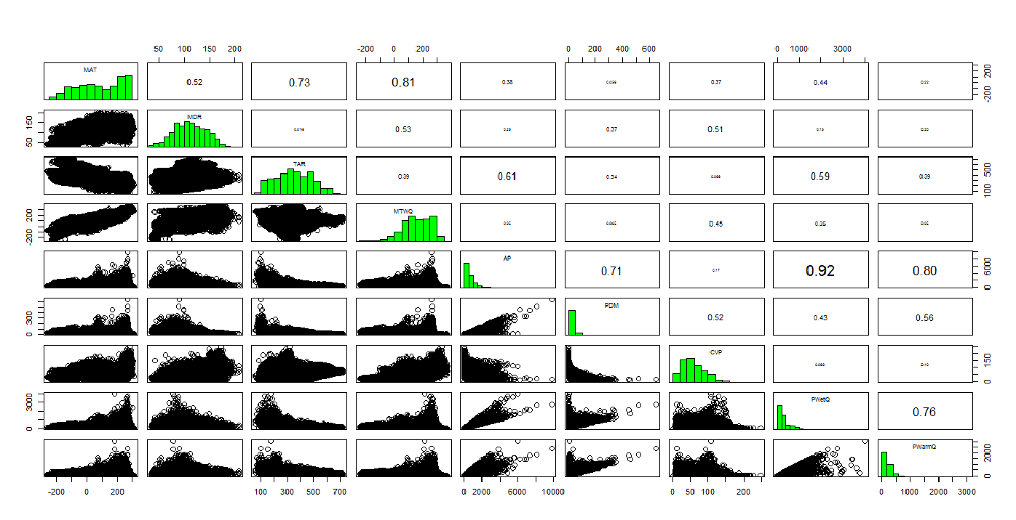

Supplemental material 2
The International Drought Experiment (IDE) sites cover 6 continental regions: North America (35), Central and South America (26), Europe (29), Africa (10), Australia (7), Asia and Middle-East (20) (figure S2). Sites span over 85° in absolute latitude (actual latitudes 48.5° N to 37.7° S), mean annual temperature of -6.2 – 27.1° C, and nearly 2,400 mm of mean annual precipitation, from approximately 100 - 2,500 mm.yr⁻¹. They include diverse ecosystems, from deserts to forests, and encompass a broad range of aridity conditions described by the aridity index, from hyperarid to humid bioclimatic zones (table S5).

Table S5: The IDE sites and their geographical locations. For each site, geographic location, mean climatic variables, and ecosystems are specified, including the aridity index to classify bioclimatic zones (AI=MAP/PET; Le Houérou 1996). MAT: mean annual temperature (℃); MAP: mean total annual precipitation (mm.yr⁻¹).

Site name | Country | Continent | Ecosystem | Longitude | Latitude | MAT | MAP | AI
Al-Aroob | Egypt | Africa | Desert | 31.37 | 30.07 | 21.5 | 22 | 0.01
Al-Arkop | Egypt | Africa | Desert | 31.375 | 30.072 | 21.5 | 22 | 0.01
FuKang | Uzbekistan | Asia | Desert | 57.53 | 44.26 | 10.2 | 129 | 0.12
Fukang Field | China | Asia | Desert | 87.917 | 44.117 | 7.5 | 195 | 0.19
Mori | China | Asia | Desert | 90.72 | 43.86 | 5.8 | 98 | 0.1
P.St. Gracia | Chile | South A. | Desert | -71.074 | -29.781 | 14.6 | 77 | 0.07
AAF | Canada | North A. | Grassland | -107.728 | 50.288 | 3.5 | 355 | 0.45
Alaxanyouqi | China | Asia | Grassland | 99.733 | 38.633 | -2 | 307 | 0.46
Bad Lauchstaedt | Germany | Europe | Grassland | 11.878 | 51.392 | 8.9 | 493 | 0.66
Bayreuth | Germany | Europe | Grassland | 11.345 | 49.552 | 8.2 | 680 | 0.87
Blair Flats P. | Canada | North A. | Grassland | -80.374 | 43.385 | 6.9 | 905 | 1.05
BNZ-FP3A | USA | North A. | Grassland | -148.151 | 64.723 | -3 | 304 | 0.54
BNZ-UP2A | USA | North A. | Grassland | -148.356 | 64.695 | -3.3 | 304 | 0.55
Bogong High P. | Australia | Australia | Grassland | 147.256 | -36.874 | 6.5 | 1507 | 1.81
Bonanza Creek | USA | North A. | Grassland | -147.25 | 64.75 | -3.5 | 349 | 0.66
Borana | Ethiopia | Africa | Grassland | 38.153 | 4.876 | 19.4 | 557 | 0.35
Brookdale | Canada | North A. | Grassland | -99.92 | 50.051 | 1.5 | 473 | 0.61
Cedar Creek | USA | North A. | Grassland | -93.211 | 45.425 | 6.2 | 749 | 0.83
C. Mongolia | Mongolia | Asia | Grassland | 100.93 | 47.78 | -1.2 | 303 | 0.44
Cerecita | Ecuador | South A. | Grassland | -80.31 | -2.275 | 24.5 | 641 | 0.41
Changling | China | Asia | Grassland | 123.519 | 44.574 | 5.4 | 435 | 0.49
CBGB | USA | North A. | Grassland | -93.387 | 41.792 | 9.1 | 850 | 0.84
Clarkston | USA | North A. | Grassland | -112.043 | 41.898 | 6.9 | 460 | 0.42
Duolun | China | Asia | Grassland | 116.28 | 42.03 | 1.6 | 391 | 0.49
Ea. S.P. Valdes | Argentina | South A. | Grassland | -65.06 | -42.778 | 13.5 | 161 | 0.14
REGUA | Brazil | South A. | Grassland | -42.717 | -22.417 | 22.3 | 1429 | 0.98
Guapiaçu | Brazil | South A. | Grassland | -42.717 | -22.417 | 22.3 | 1429 | 0.98
Guapiaçu | Brazil | South A. | Grassland | -42.716 | -22.416 | 20.1 | 1520 | 1.05
E. Sc.W. | Canada | North A. | Grassland | -81.34 | 43.08 | 7.3 | 947 | 1.09
Ethabuka | Australia | Australia | Grassland | 138.474 | -23.756 | 23.7 | 205 | 0.11
Fenghuoshan | China | Asia | Grassland | 92.833 | 34.667 | -6.2 | 292 | 0.6
Rhine River | Germany | Europe | Grassland | 8.446 | 49.823 | 9.9 | 595 | 0.73
Fort Rijnauwen | Netherlands | Europe | Grassland | 5.176 | 52.074 | 9.3 | 801 | 1.15
Freiburg | Germany | Europe | Grassland | 7.827 | 48.02 | 10.5 | 841 | 1.02
Garraf | Spain | Europe | Grassland | 1.818 | 41.303 | 15.5 | 630 | 0.7
Golestan Park | Iran | Asia | Grassland | 56.21 | 37.38 | 11.2 | 233 | 0.19
Freiburg | Germany | Europe | Grassland | 7.826 | 48.02 | 10.5 | 841 | 1.02
Hong Yuan | China | Asia | Grassland | 102.55 | 32.8 | 3.4 | 742 | 0.81
Horizontes | Costa Rica | South A. | Grassland | -85.55 | 10.71 | 25.9 | 1709 | 0.98
I. Mongolia | China | Asia | Grassland | 116 | 43 | 1.4 | 330 | 0.4
Iowa Lakeside | USA | North A. | Grassland | -95.183 | 43.379 | 7.1 | 722 | 0.75
Jena | Germany | Europe | Grassland | 11.32 | 50.56 | 7 | 705 | 0.97
Jornada Basin | USA | North A. | Grassland | -106.746 | 32.532 | 15 | 253 | 0.16
Kessler Atm. | USA | North A. | Grassland | -97.52 | 34.97 | -3.2 | 344 | 0.57
Kinsella | Canada | North A. | Grassland | -111.56 | 53.033 | 2 | 429 | 0.6
Kiskunsag | Hungary | Europe | Grassland | 19.422 | 46.871 | 10.9 | 536 | 0.59
Konza Prairie | USA | North A. | Grassland | -96.614 | 39.105 | 12.2 | 863 | 0.74
Lac du Bois | Canada | North A. | Grassland | -120.44 | 50.789 | 5.9 | 343 | 0.43
Lambwe Valley | Kenya | Africa | Grassland | 34.253 | -0.607 | 22.2 | 1218 | 0.68
Las Chilcas | Argentina | South A. | Grassland | -58.266 | -36.276 | 15.1 | 926 | 0.72
Loma Ridge | USA | North A. | Grassland | -117.7 | 33.74 | 16.7 | 402 | 0.3
Long Branch | USA | North A. | Grassland | -121.015 | 42.181 | 6.4 | 435 | 0.41
Maodeng farm | China | Asia | Grassland | 116.485 | 44.163 | 1.3 | 307 | 0.36
Mar Chiquita | Argentina | South A. | Grassland | -57.425 | -37.715 | 13.9 | 842 | 0.75
Matta Judean | Israel | Europe | Grassland | 35.066 | 31.713 | 18 | 486 | 0.36
Mattheis | Canada | North A. | Grassland | -111.884 | 50.896 | 3.8 | 323 | 0.38
Met European | Italy | Europe | Grassland | 14.742 | 41.107 | 14.7 | 785 | 0.78
Middle Ebro V. | Spain | Europe | Grassland | 0.701 | 41.654 | 15 | 441 | 0.38
Mols | Denmark | Europe | Grassland | 10.572 | 56.23 | 7.5 | 591 | 1.02
Mu Us Sand | China | Asia | Grassland | 109.4 | 39.05 | 7.2 | 373 | 0.37
Naposta | Argentina | South A. | Grassland | -62.288 | -38.427 | 14.7 | 654 | 0.51
Pfynwald | Switzerland | Europe | Grassland | 7.61 | 46.3 | 8 | 926 | 1.17
Pineta | Somalia | Africa | Grassland | 42.658 | 0.115 | 27.5 | 499 | 0.29
Potrok aike | Argentina | South A. | Grassland | -70.41 | -51.92 | 6.4 | 203 | 0.29
Purdue | USA | North A. | Grassland | -87.052 | 40.447 | 10.2 | 950 | 0.91
Quamichan | Canada | North A. | Grassland | -123.633 | 48.808 | 9.3 | 1177 | 1.53
Guaribas | Brazil | South A. | Grassland | -34.863 | -7.139 | 25.3 | 1936 | 1.31
Richland | USA | North A. | Grassland | -90.47 | 43.34 | 7.1 | 839 | 0.89
San Claudio | Argentina | South A. | Grassland | -60.792 | -35.436 | 15.8 | 1043 | 0.77
Schynige P. | Switzerland | Europe | Grassland | 7.908 | 46.655 | 5.7 | 1309 | 2.7
Shapotou | China | Asia | Grassland | 104.43 | 37.5 | 7.7 | 205 | 0.2
Sierra de G. | Spain | Europe | Grassland | -3.956 | 40.833 | 6.5 | 701 | 0.82
Sra. Foothill | USA | North A. | Grassland | -121.312 | 39.249 | 15.9 | 842 | 0.63
South Africa | South Africa | Africa | Grassland | 28.267 | -25.75 | 17.2 | 713 | 0.47
Stengl Lost | USA | North A. | Grassland | -97.17 | 30.086 | 19.6 | 926 | 0.62
SUMO | China | Asia | Grassland | 106.3 | 34.3 | 9.1 | 681 | 0.75
Syferkuil | South Africa | Africa | Grassland | 29.698 | -23.848 | 16.7 | 836 | 0.6
Tai Po Kau | Hong Kong | Asia | Grassland | 114.174 | 22.421 | 22.1 | 2223 | 2.02
Teshio | Japan | Asia | Grassland | 142.019 | 44.918 | 6.2 | 1223 | 1.95
THUN | Switzerland | Europe | Grassland | 7.588 | 46.746 | 8.5 | 929 | 1.19
Tucker Prairie | USA | North A. | Grassland | -91.991 | 38.95 | 11.9 | 983 | 0.87
UDELAR | Uruguay | South A. | Grassland | -57.97 | -31.38 | 18.6 | 1287 | 0.89
UF Bivens | USA | North A. | Grassland | -82.353 | 29.629 | 20.4 | 1334 | 0.88
Ukulinga | South Africa | Africa | Grassland | 30.4 | -29.67 | 17.9 | 882 | 0.63
UFRGS | Brazil | South A. | Grassland | -51.677 | -30.099 | 19.4 | 1359 | 1.06
Uf Saskatchewan | Canada | North A. | Grassland | -106.717 | 51.91 | 2.2 | 346 | 0.45
Uf Saskatchewan | Canada | North A. | Grassland | -106.53 | 52.16 | 1.9 | 358 | 0.47
Uf Saskatchewan | Canada | North A. | Grassland | -107.73 | 50.698 | 3.5 | 339 | 0.42
Valdemoro | Spain | Europe | Grassland | -3.601 | 40.19 | 14.4 | 422 | 0.37
Validate | France | Europe | Grassland | 3.023 | 45.723 | 8 | 799 | 0.99
Waterberg | Namibia | Africa | Grassland | 17.217 | -20.417 | 18.7 | 440 | 0.25
WSL MODEK | Switzerland | Europe | Grassland | 8.28 | 47.22 | 8.4 | 1163 | 1.6
Xalapa | Mexico | South A. | Grassland | -96.91 | 19.54 | 18.5 | 1596 | 1.22
Yarramundi | Australia | Australia | Grassland | 150.738 | -33.614 | 17.2 | 894 | 0.66
Zedelgem | Belgium | Europe | Grassland | 3.118 | 51.147 | 10.1 | 713 | 1.12
Lygra | Norway | Europe | Heathland | 5.097 | 60.7 | 7.7 | 2095 | NA
Lygra | Norway | Europe | Heathland | 5.5 | 60.42 | 6.9 | 2383 | 5.25
Brandbjerg | Denmark | Europe | Shrubland | 11.97 | 55.88 | 8.2 | 603 | 1.13
Casper Mount | USA | North A. | Shrubland | -106.352 | 42.728 | 3.9 | 401 | 0.47
C. Fortunoso | Argentina | South A. | Shrubland | -68.982 | -37.305 | 13.9 | 152 | 0.11
Chacra Pat. | Argentina | South A. | Shrubland | -62.899 | -40.723 | 14.1 | 337 | 0.28
Cro Rivadavia | Argentina | South A. | Shrubland | -67.5 | -45.867 | 12.3 | 228 | 0.24
CredoJ | Australia | Australia | Shrubland | 120.808 | -30.46 | 18.5 | 265 | 0.17
CredoM | Australia | Australia | Shrubland | 120.9 | -30.47 | 18.4 | 266 | 0.17
EEA Sta Cruz | Argentina | South A. | Shrubland | -70.407 | -51.916 | 6.4 | 201 | 0.29
Ea Los pozos | Argentina | South A. | Shrubland | -69.265 | -51.393 | 6.8 | 219 | 0.29
Hardware Ranch | USA | North A. | Shrubland | -111.567 | 41.614 | 4.9 | 443 | 0.42
Los Cerrillos | Argentina | South A. | Shrubland | -65.897 | -29.961 | 20.4 | 392 | 0.25
Mt Oriental | Argentina | South A. | Shrubland | -64.854 | -39.683 | 15 | 276 | 0.2
Neds Corner | Australia | Australia | Shrubland | 141.302 | -34.136 | 17.3 | 273 | 0.19
North Platte | USA | North A. | Shrubland | -106.564 | 42.713 | 7.3 | 287 | 0.26
Ordesa | Spain | Europe | Shrubland | 42.651 | -0.069 | 27.1 | 449 | 0.28
La Campana | Chile | South A. | Shrubland | -71.086 | -32.934 | 13.1 | 387 | 0.29
Punta Ninfas | Argentina | South A. | Shrubland | -64.583 | -43 | 12.9 | 186 | 0.17
Rio Mayo | Argentina | South A. | Shrubland | -71.1 | -45.583 | 7.4 | 365 | 0.45
Sevilleta | USA | North A. | Shrubland | -106.833 | 34.333 | 13 | 234 | 0.15
Tabernas | Spain | Europe | Shrubland | -2.355 | 37.091 | 15.8 | 330 | 0.3
Castanopsis | China | Asia | Forest | 117.467 | 26.183 | 19.2 | 1658 | 1.27
Filii | Spain | Europe | Forest | 0.961 | 42.464 | 4.9 | 1193 | 1.88
Griffy Woods | USA | North A. | Forest | -86.5 | 39.19 | 11.5 | 1105 | 1
Jura | Switzerland | Europe | Forest | 6.566 | 46.838 | 4.7 | 1526 | 2.31
Lancaster | UK | Europe | Forest | -2.777 | 54.014 | 8.6 | 1147 | 1.87
Mt. Gongga | China | Asia | Forest | 101.883 | 29.6 | -7.4 | 1123 | 9.94
Wombate | Australia | Australia | Forest | 144.182 | -37.419 | 10.7 | 1135 | 1.1
Yatir Forest | Israel | Europe | Forest | 35.052 | 31.345 | 17.8 | 298 | 0.21
Figure S2. The IDE sites distributed in geographical space. (Google. (n.d.). Retrieved August 4, 2017, from http://drought-net.org/locations)).

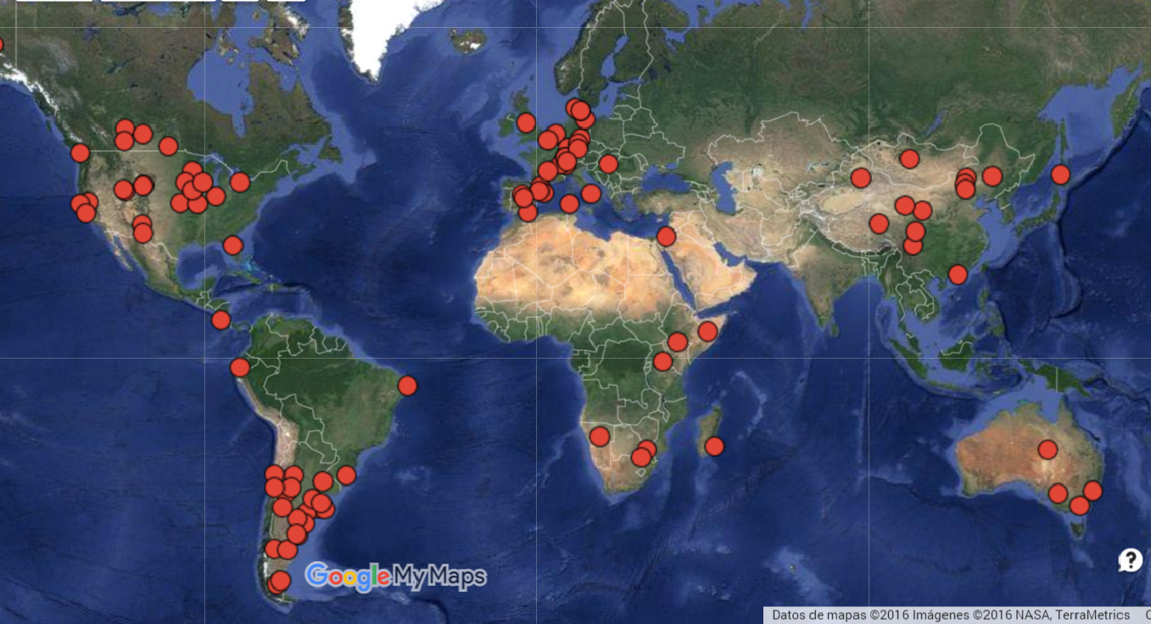

References
Le Houérou HN. 1996. Climate change, drought and desertification. Journal of Arid Environments, 34: 133–185.
R Core Team. 2018. R: A language and environment for statistical computing. R Foundation for Statistical Computing, Vienna, Austria. URL https://www.R-project.org/.

