**Appendix A. Supplementary Material**

**Appendix A1.** Face to face survey.

April 25th , 2019 SURVEY NUMBER ...........................

*We are working on a study on the perception that society has about different landscapes in the province of Almería. For that reason, we are surveying both local population and visitors. It would be very helpful for us to know your perception through this survey. Would you be so kind to answer it? Thank you very much! Remember that all responses are anonymous. There are no "wrong answers", just tell us what you think.*

1. How connected do you feel with nature? (*Choose one of the five options*)

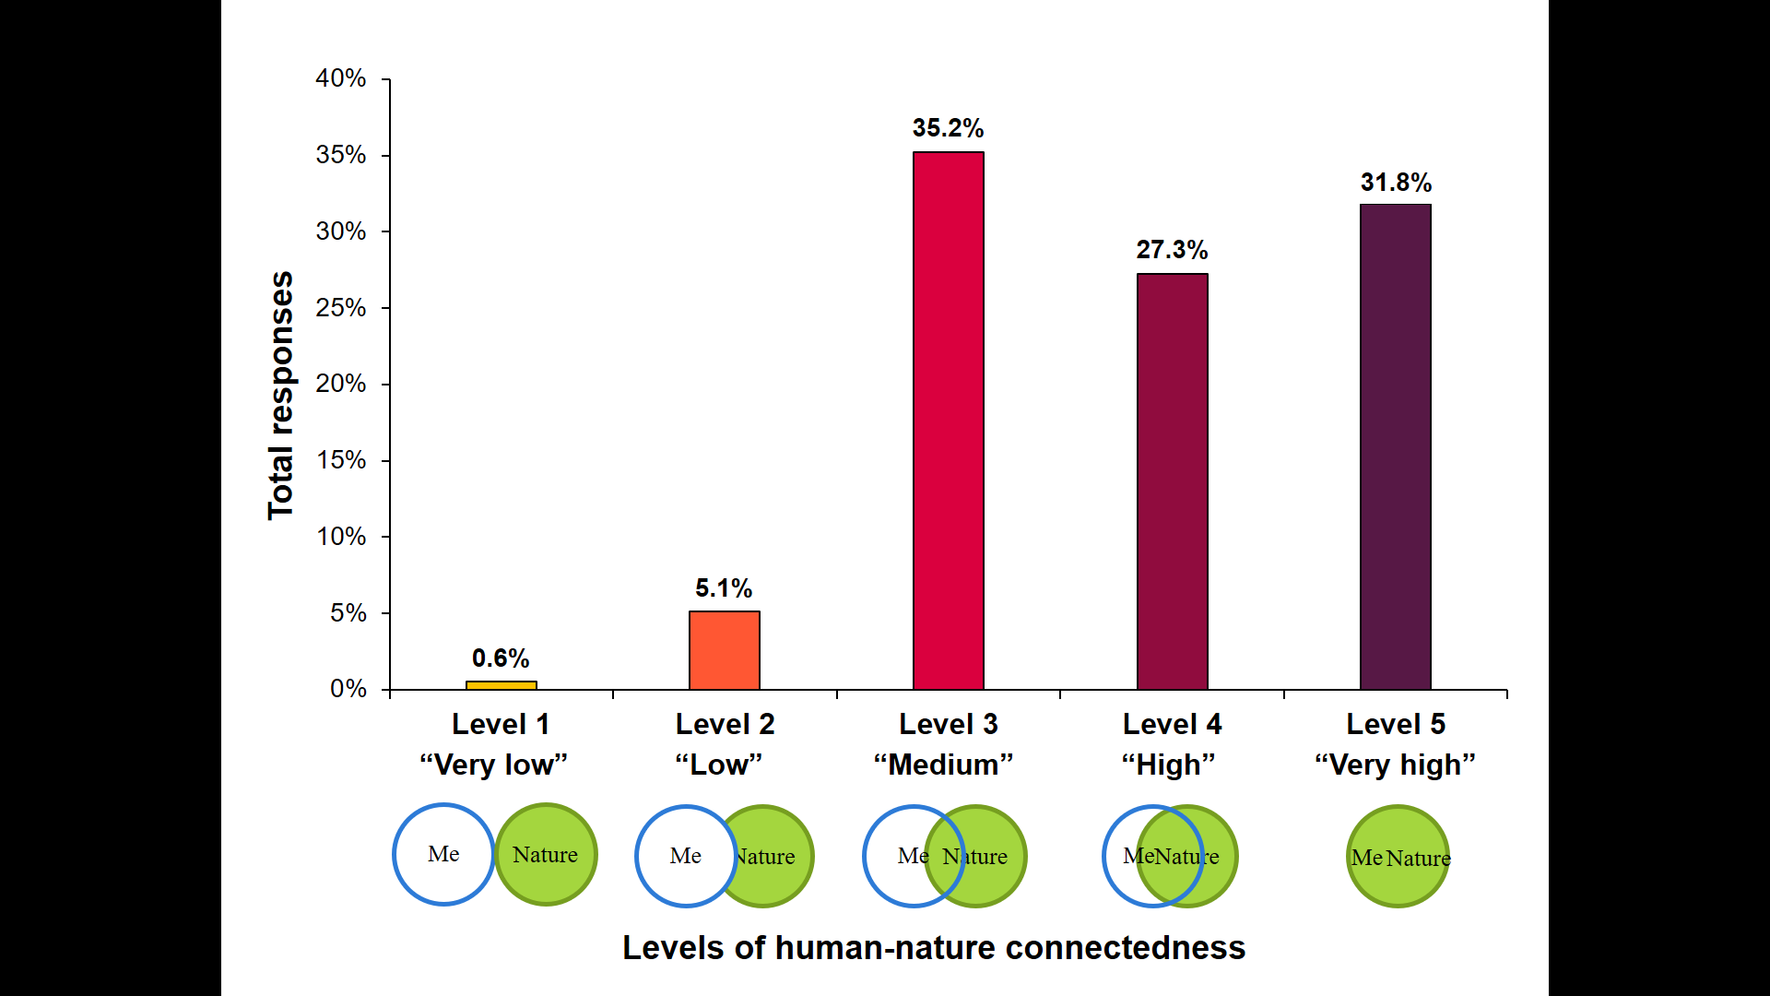

2. Could you explain (in your own words) why you have chosen that answer?......................................................................................................................................................................................................................................................................................................................................................................

3. How much time do you spend outdoors (in open environments) on a regular day?

□ Less than 0,5 hour per day □ 2 - 4 hours per day

□ 0,5 - 2 hours per day □ More than 4 hours per day

4. How much time do you spend outdoors (in open environments) in your free time (weekends, holidays, etc.)?

□ Less than 0,5 hour per day □ 2 - 4 hours per day

□ 0,5 - 2 hours per day □ More than 4 hours per day

5. What is your favorite landscape in Almería? (*The panel of landscapes and emotions is not used for this question. Note down all the landscapes mentioned*) ..........................................................................................................................................................................................................................................................................................

Why?.................................................................................................................................................................................................................................................................................

6. What is your least favorite landscape in Almería? (*The panel of landscapes and emotions is not used for this question. Note down all the landscapes mentioned*) ..........................................................................................................................................................................................................................................................................................

Why?.................................................................................................................................................................................................................................................................................

7. Which emotions do these landscapes inspire you? Why? (*Show the panel of landscapes and emotions to the respondent and note down the answers of the whys in the following table*)

|  |  |
| --- | --- |
| **LANDSCAPES** | **WHY THESE EMOTIONS?** |
| **Greenhouses** |  |
| **Open-air agriculture** |  |
| **Tabernas Desert and Badlands** |  |
| **Marine and Coastal Protected Areas** |  |
| **Non-Protected Littoral** |  |
| **Mediterranean Forest** |  |
| **Wetlands** |  |
| **Intermittent streams** |  |
| **High Mountains** |  |
| **Mediterranean Shrubland** |  |

8. Which of these landscapes do you consider important? Why? *(Show the panel of landscapes and note down the answers of the whys in the following table*)

|  |  |
| --- | --- |
| **LANDSCAPES** | **WHY THESE EMOTIONS?** |
| **Greenhouses** |  |
| **Open-air agriculture** |  |
| **Tabernas Desert and Badlands** |  |
| **Marine and Coastal Protected Areas** |  |
| **Non-Protected Littoral** |  |
| **Mediterranean Forest** |  |
| **Wetlands** |  |
| **Intermittent streams** |  |
| **High Mountains** |  |
| **Mediterranean Shrubland** |  |

9. Could you tell me which your level of formal studies is?

|  |  |  |
| --- | --- | --- |
| No studies | Elementary School | High School (Junior) |
| High School (Senior) / Middle vocational training | Superior vocational training | University |

Others: ...............................................................................................................

|  |  |
| --- | --- |
| Place of birth | Place of residence |
| Age | Gender |

10. Where do you feel from? ………………………………………………………………………………………….

**Appendix A2.** Photo-panel with landscapes and set of emotions.

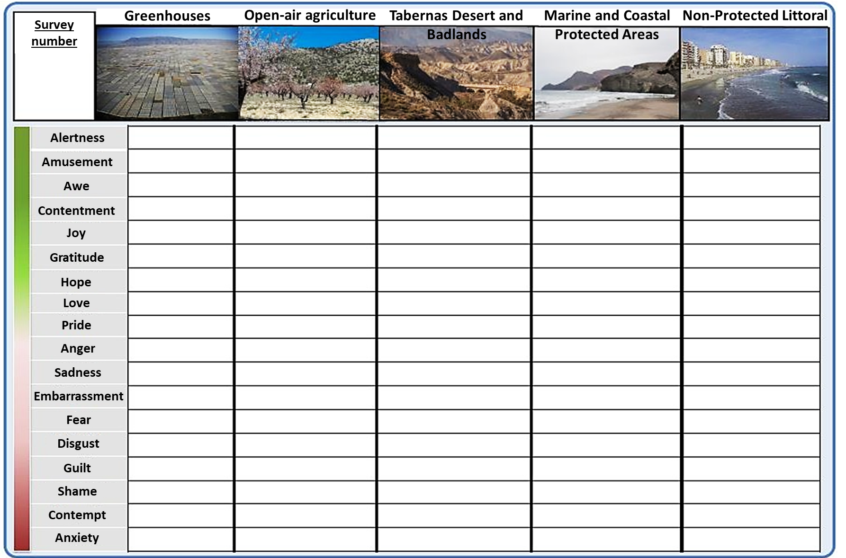

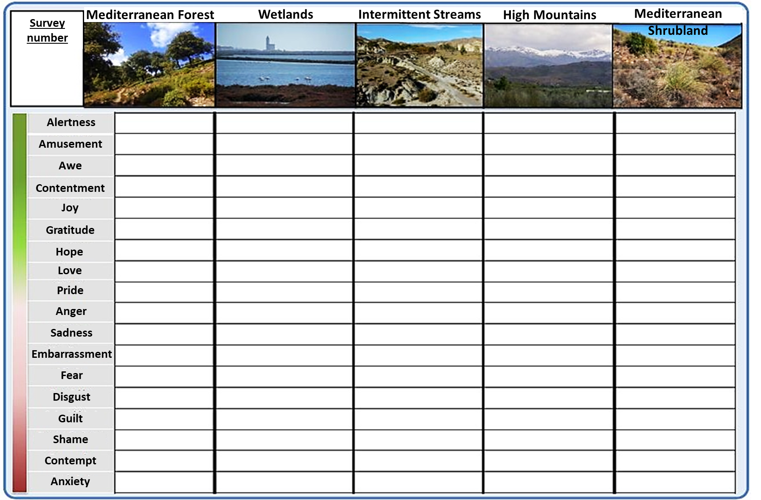

**Appendix A3.** Table of CORINE land cover type and the European natural habitat types of community interest (HCI) for landscape classification in PAs.

https://drive.google.com/file/d/10yZqcuvPVp-7RMbmb379LlBs6LLunlmb/view?usp=drive_link

**Appendix A4.** The spatial distribution of emotions scores across the PAs

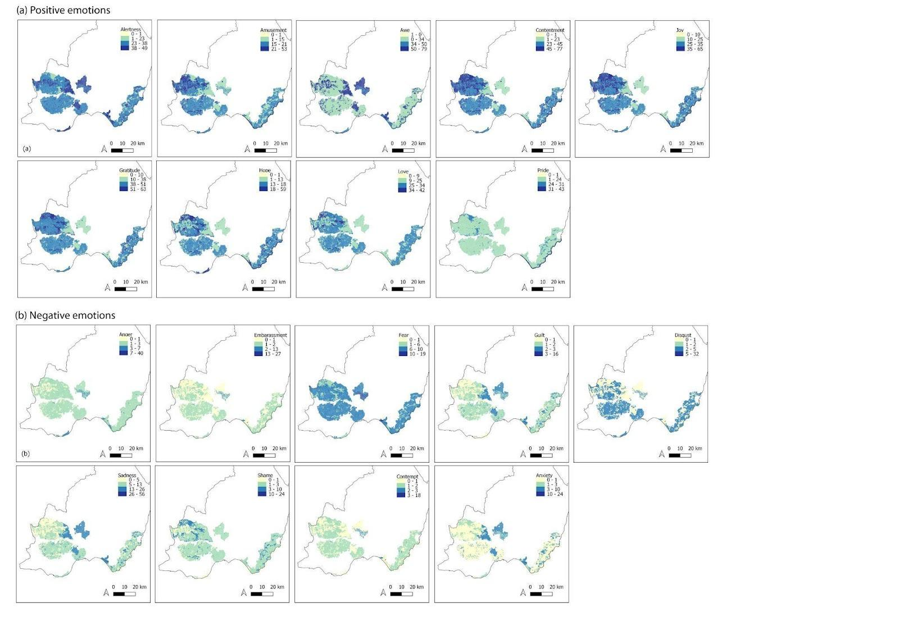

**Appendix A5.** Heatmap scores representing individual emotions in PA. The scores represent the sum of each individual emotion associated with the landscapes in each PA, weighted for the area occupied by each landscape in each PA.

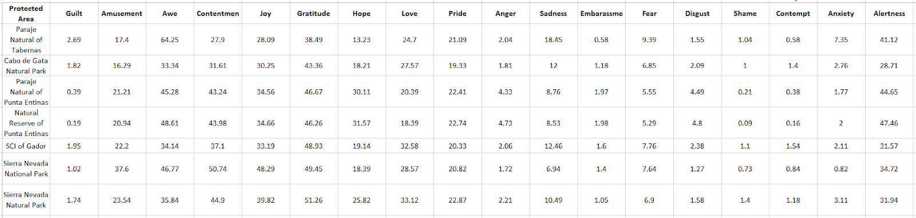

**Appendix A6.**  Spatial pattern of the ENRI score across the selected PAs. Positive values represent positive emotional relations with a specific landscape (prevalence of associated positive emotions), while negative values indicate negative emotional relations (prevalence of associated negative emotions). Values close to zero show a polarized emotional relationship, with a similar distribution of associated positive and negative emotions with specific landscapes. PAs: 1. Natural Reserve of Punta Entinas-Sabinar; 2. National Park of Sierra Nevada; 3. Natural Park of Sierra Nevada; 4. Natural Park of Cabo de Gata; 4. Paraje Natural of Tabernas; 6. Paraje Natural of Punta Entinas-Sabinar: 7. SCI of Gador

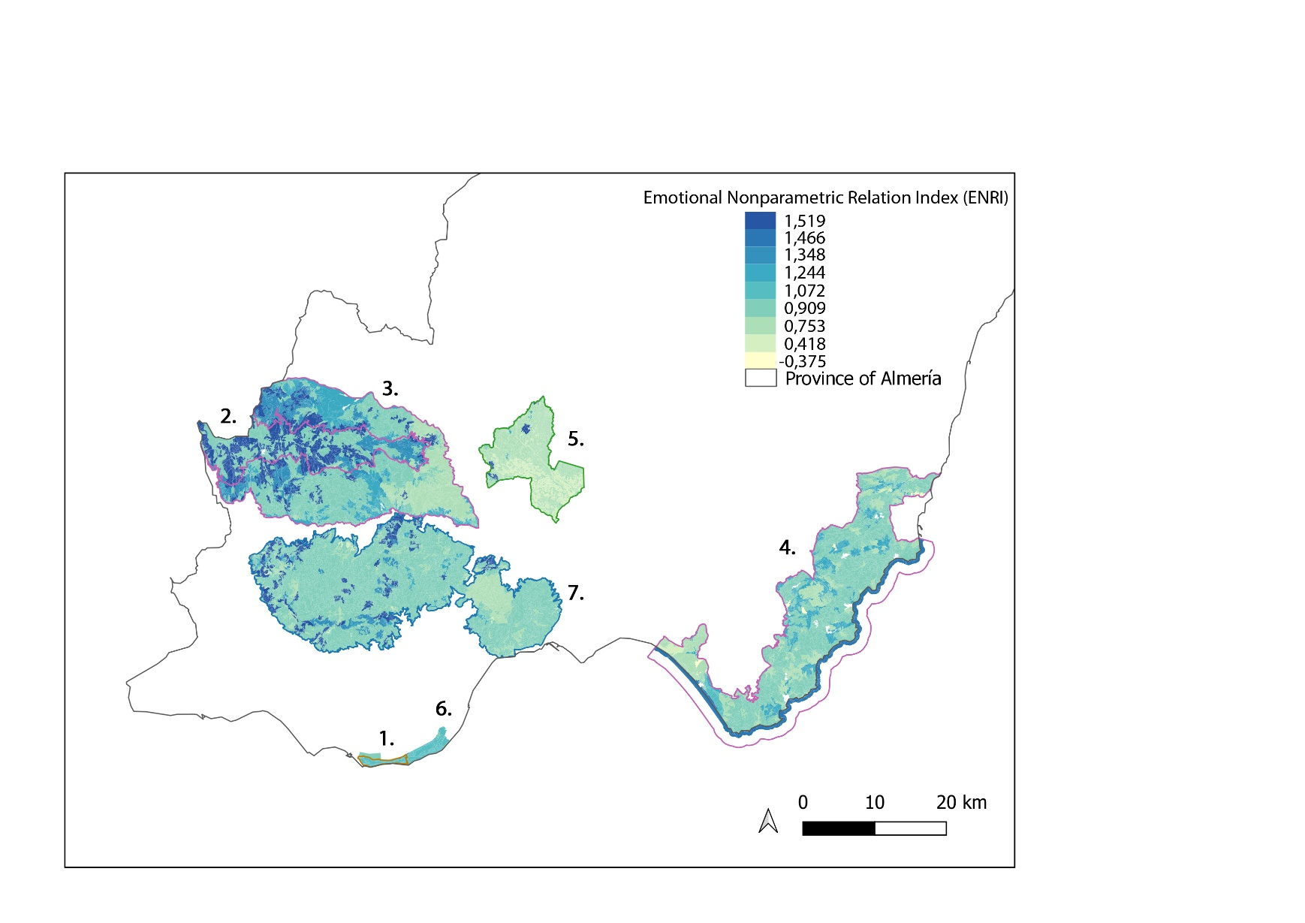

**Appendix A7.** The Martonne Aridity Index calculated by PA

|  |  |
| --- | --- |
| **Protected area** | **Aridity  Index per PA** |
| Sierra Nevada National Park | 1,239 |
| Sierra Nevada Natural Park | 1,074 |
| Natural Reserve of punta Entinas | 1,056 |
| Paraje Natural of Punta Entinas | 1,039 |
| Cabo de Gata Natural Park | 0,946 |
| SCI of Gador | 0,941 |
| Paraje Natural of Tabernas | 0,629 |